The Prompt which I used for Jira Integration is given below :

Prompt.
Act as a Architect and enhance this application
First complete the plan and then we will go for implementation.
This is a RAG pipeline ingestion application which converts the test cases and User stories to json format and then create Mongodb embeddings. Then user will be able to Retrieve Existing Context from MongoDB.
I want a new feature in this application
1. Introduce a option in left pane to Integrate with jira and fetch the userstory details using Jira-url, Apikey, Jira email, US number
2. Then convert the US details to JSON format as like "Convert to JSON" menu does and place the converted file under src/data folder
3. Then I will use the same existing Embedding & store option to ingest the US json file to Mongodb.
4. Use the Jira user story along with the retrieved context to *generate test cases* using the existing functionality under Prompt & Schema menu
5. Display the generated test cases in the frontend under Prompt & Schema menu.

After Vibe coding , New menu Jira Import is created
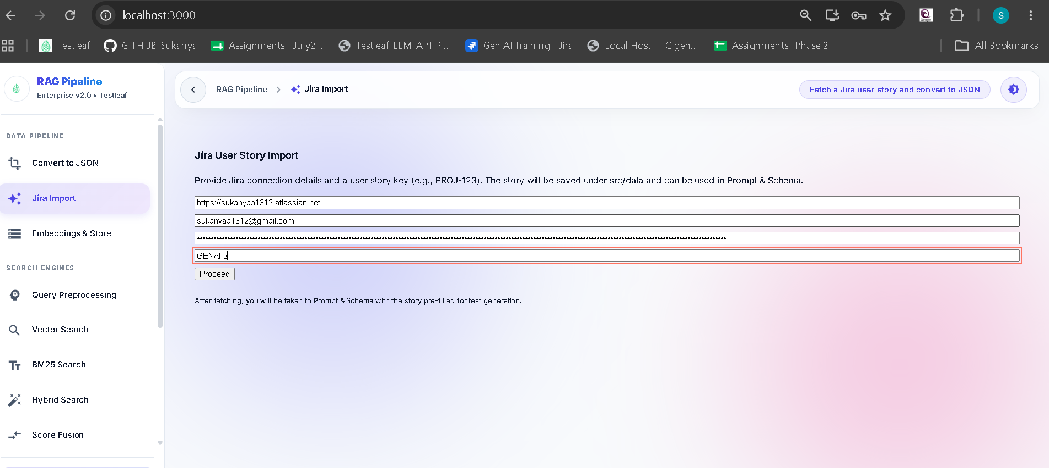

Json format of the jira story is created and it is available for embedding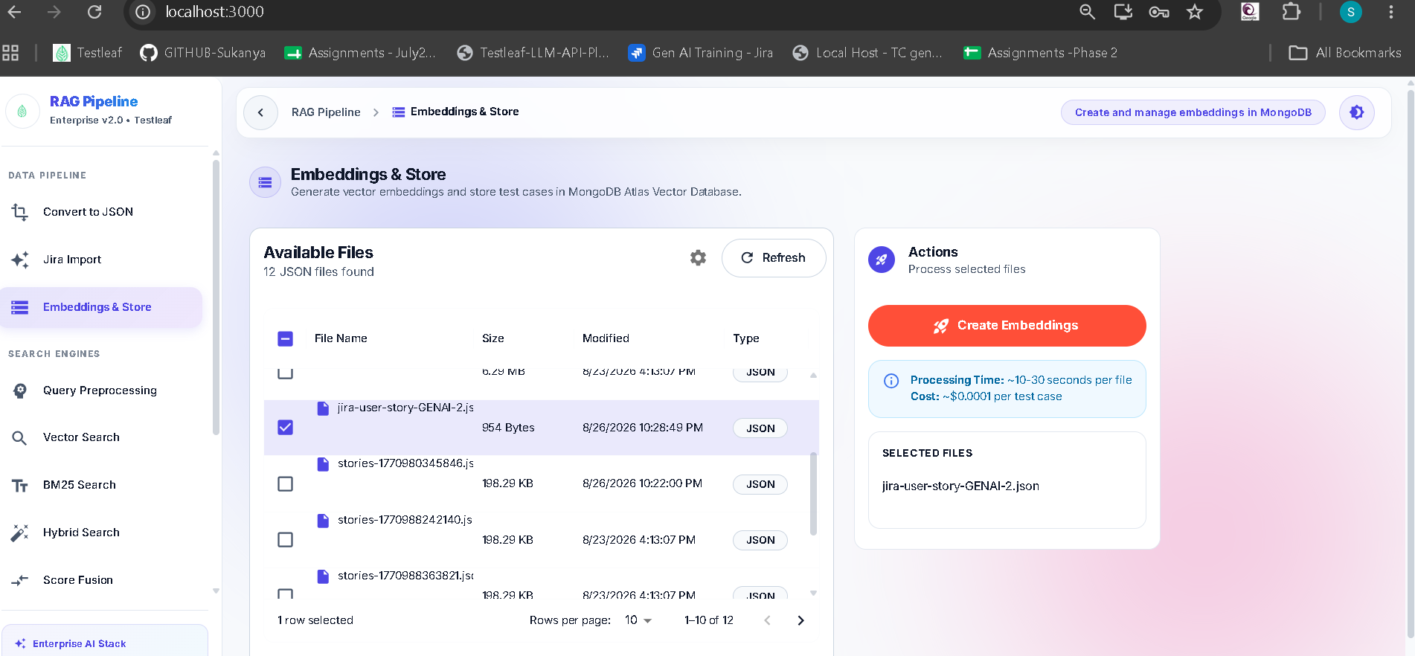

Now embedding process is started
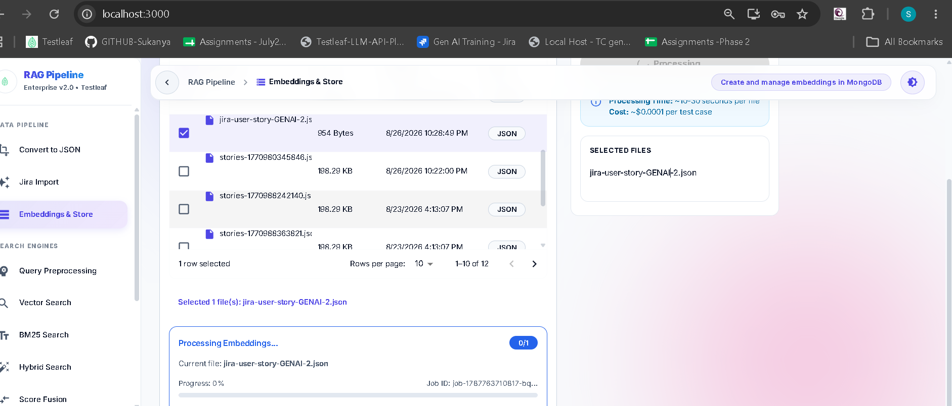

User story – Vector embedding is created
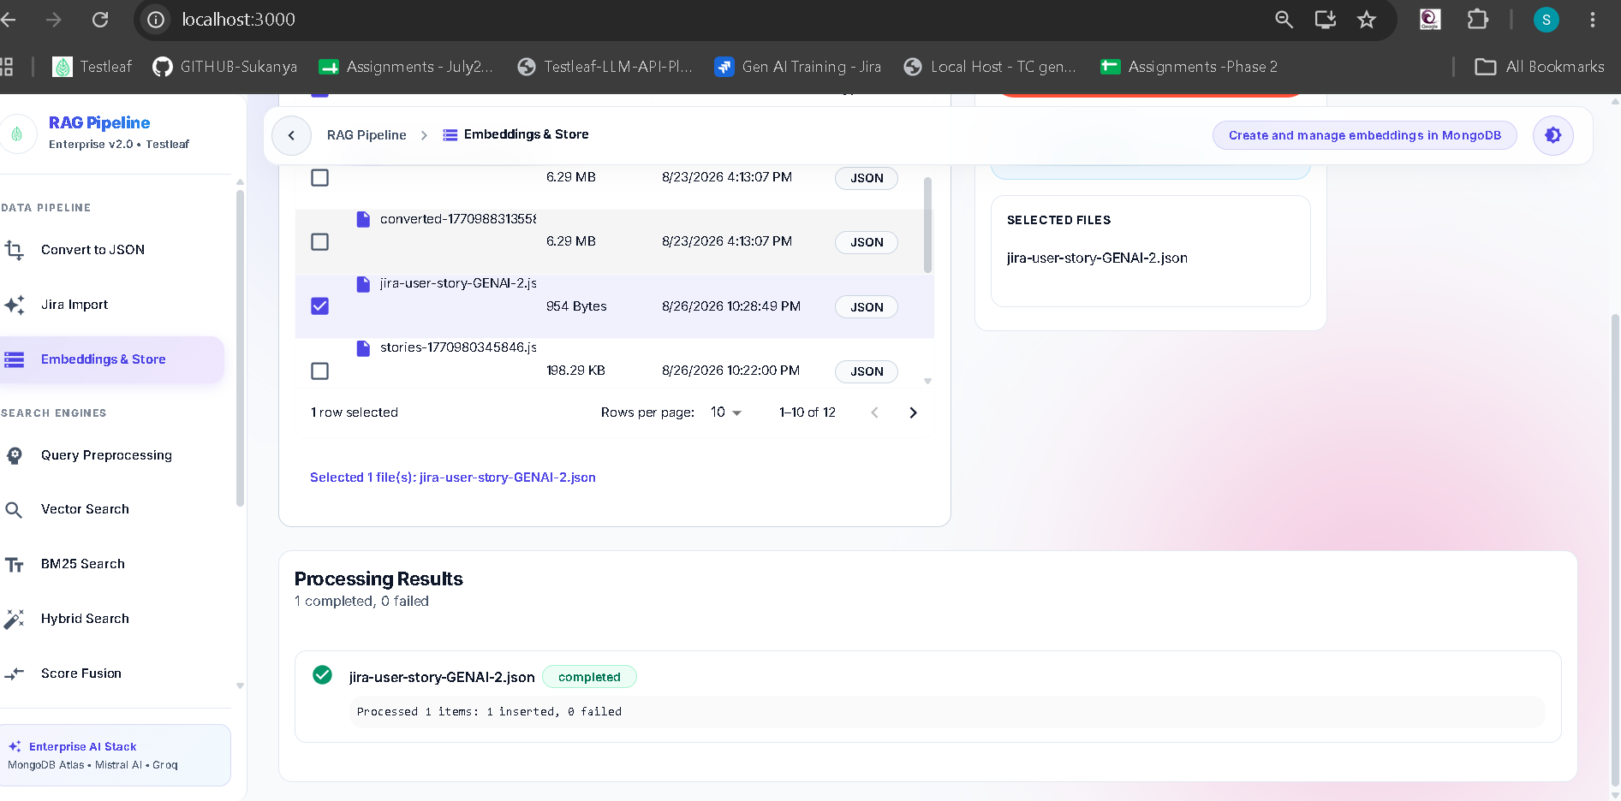

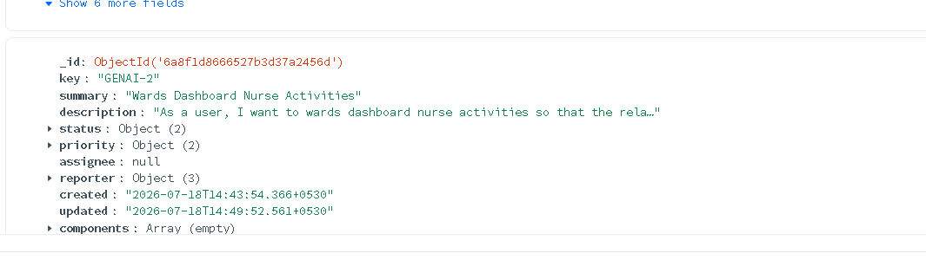
Now RAG context retrieved and Test cases are generated
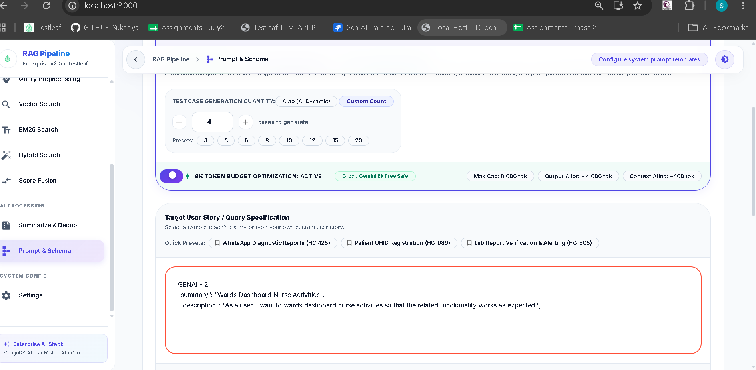
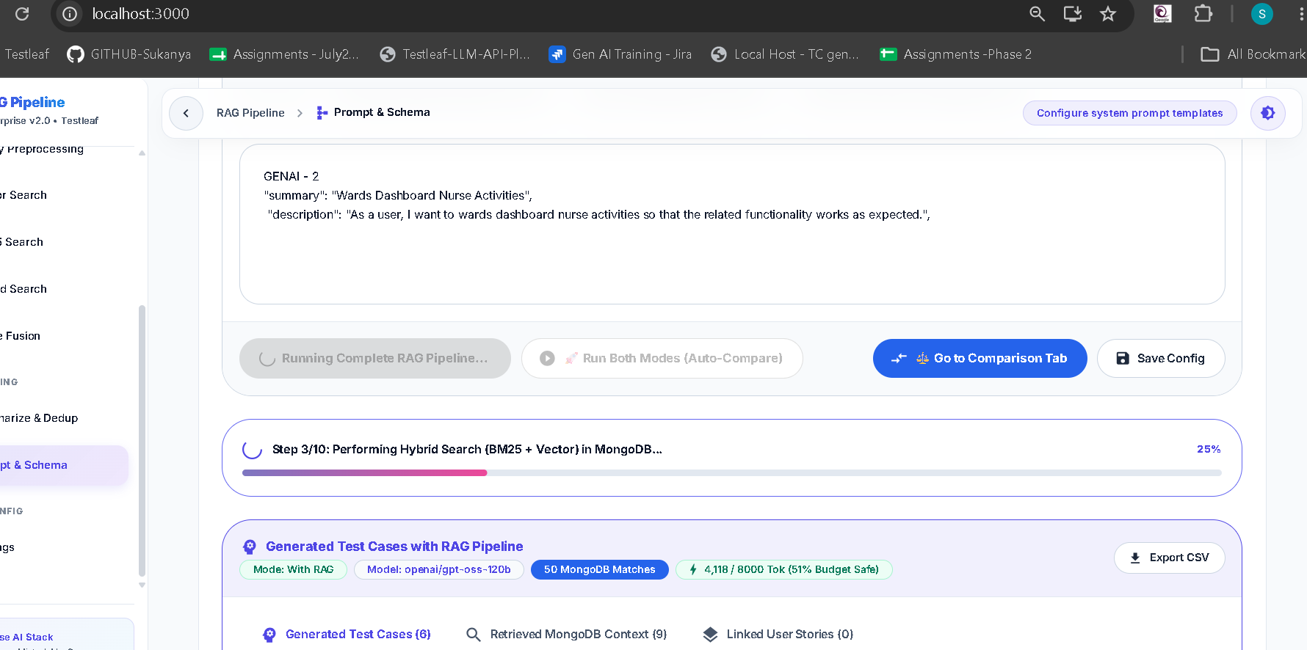

Finally Test cases are generated
